CHAPTER 18

TEACHING NOTES

Several of the topics in this chapter, including testing for unit roots and cointegration, are now staples of applied time series analysis. Instructors who like their course to be more time series oriented might cover this chapter after Chapter 12, if time permits. Or, the chapter can be used as a reference for ambitious students who wish to be versed in recent time series developments.

The discussion of infinite distributed lag models, and in particular geometric DL and rational DL models, gives one particular interpretation of dynamic regression models. But one must emphasize that only under fairly restrictive assumptions on the serial correlation in the error of the infinite DL model does the dynamic regression consistently estimate the parameters in the lag distribution. Computer Exercise C18.1 provides a good illustration of how the GDL model, and a simple RDL model, can be too restrictive.

Example 18.5 tests for cointegration between the general fertility rate and the value of the personal exemption. There is not much evidence of cointegration, which sheds further doubt on the regressions in levels that were used in Chapter 10. The error correction model for holding yields in Example 18.7 is likely to be of interest to students in finance. As a class project, or a term project for a student, it would be interesting to update the data to see if the error correction model is stable over time.

The forecasting section is heavily oriented towards regression methods and, in particular, autoregressive models. These can be estimated using any econometrics package, and forecasts and mean absolute errors or root mean squared errors are easy to obtain. The interest rate data sets (for example, INTQRT.RAW) can be updated to do much more recent out-of-sample forecasting exercises.
SOLUTIONS TO PROBLEMS

18.1 With z_{t1} and z_{t2} now in the model, we should use one lag each as instrumental variables, z_{t-1,1} and z_{t-1,2}. This gives one overidentifying restriction that can be tested.

18.2 (i) When we lag equation (18.68) once, multiply it by (1 –
λ), and subtract it from (18.68), we obtain

y_{t} – (1 – λ)y_{t-1} = λα₀ + α₁[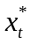– (1 – λ)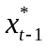] + u_{t} – (1 – λ)u_{t-1}.

But we can rewrite (18.69) as

– (1 – λ) = λx_{t-1};

when we plug this into the first equation we obtain the desired result.

(ii) If {u_{t}} is serially uncorrelated, then {v_{t} = u_{t} – (1 – λ)u_{t-1}} must be serially correlated. In fact, {v_{t}} is an MA(1) process with α = – (1 – λ). Therefore, Cov(v_{t},v_{t-1}) = – (1 – λ)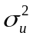, and the correlation between v_{t} and v_{t-h} is zero for h > 1.

(iii) Because {v_{t}} follows an MA(1) process, it is correlated with the lagged dependent variable, y_{t-1}. Therefore, the OLS estimators of the β_{j} will be inconsistent (and biased, of course). Nevertheless, we can use x_{t-2} as an IV for y_{t-1} because x_{t-2} is uncorrelated with v_{t} (because u_{t} and u_{t-1} are both uncorrelated with x_{t-2}) and x_{t-2}) and x_{t-2} is partially correlated with y_{t-1}.

(iv) Because 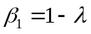, 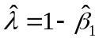. Then, because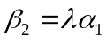, 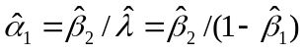. Because the plim passes through continuous functions, consistency of these estimators is immediate. None of the estimators is unbiased. For one, the OLS estimators of the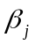 are not unbiased given that there is a lagged dependent variable. Of course, 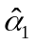 would not be unbiased even if 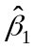 and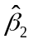 were.

18.3 For δ ≠ β, y_{t} – δz_{t} = y_{t} – βz_{t} + (β – δ)z_{t}, which is an I(0) sequence (y_{t} – βz_{t}) plus an I(1) sequence. Since an I(1) sequence has a growing variance, it dominates the I(0) part, and the resulting sum is an I(1) sequence.

18.4 Following the hint, we show that y_{t-2} – βx_{t-2} can be written as a linear function of y_{t-1} – βx_{t-1}, Δy_{t-1}, and Δx_{t-1}. That is,

y_{t-2} – βx_{t-2} = a₁(y_{t-1} – βx_{t-1}) + a₂Δy_{t-1} + a₃Δx_{t-1}

for constants a₁, a₂, and a₃. But

(y_{t-1} – βx_{t-1}) – Δy_{t-1} + βΔx_{t-1} = y_{t-1} – βx_{t-1} – (y_{t-1} – y_{t-2}) + β(x_{t-1} – x_{t-2}) = y_{t-2} – βx_{t-2},

and so a₁ = 1, a₂ = –1, and a₃ = β work in the first equation.

18.5 Following the hint, we have

y_{t} – y_{t-1} = βx_{t} – βx_{t-1} + βx_{t-1} – y_{t-1} + u_{t}

or

Δy_{t} = βΔx_{t} – (y_{t-1} – βx_{t-1}) + u_{t}.

Next, we plug in Δx_{t} = γΔx_{t-1} + v_{t} to get

Δy_{t} = β(γΔx_{t-1} + v_{t}) – (y_{t-1} – βx_{t-1}) + u_{t}
= βγΔx_{t-1} – (y_{t-1} – βx_{t-1}) + u_{t} + βv_{t}
≡ γ₁Δx_{t-1} + δ(y_{t-1} – βx_{t-1}) + e_{t},

where γ₁ = βγ, δ = –1, and e_{t} = u_{t} + βv_{t}.

18.6 (i) This is given by the estimated intercept, 1.54. Remember, this is the percentage growth at an annualized rate. It is statistically different from zero since t = 1.54/.56 = 2.75.

(ii) 1.54 + .031(10) = 1.85. As an aside, you could obtain the standard error of this estimate by running the regression.

pcip_{t} on pcip_{t-1}, pcip_{t-2}, pcip_{t-3}, (pcsp_{t-1} – 10),

and obtaining the standard error on the intercept.

(iii) Growth in the S&P 500 index has a statistically significant effect on industrial production growth – in the Granger causality sense – because the t statistic on pcsp_{t-1} is about 2.38. The economic effect is reasonably large.

18.7 If unem_{t} follows a stable AR(1) process, then this is the null model used to test for Granger causality: under the null that gM_{t} does not Granger cause unem_{t}, we can write

unem_{t} = β₀ + β₁unem_{t-1} + u_{t}
E(u_{t}|unem_{t-1}, gM_{t-1}, unem_{t-2}, gM_{t-2}, ) = 0

and |β₁| < 1. Now, it is up to us to choose how many lags of gM to add to this equation. The simplest approach is to add gM_{t-1} and to do a t test. But we could add a second or third lag (and probably not beyond this with annual data), and compute an F test for joint significance of all lags of gM_{t}.

18.8 (i) Following the hint we have

y_{t} = α + δ₁z_{t-1} + u_{t} = α + δ₁z_{t-1} + ρu_{t-1} + e_{t}
= α + δ₁z_{t-1} + ρ(y_{t-1} – α – δ₁z_{t-2}) + e_{t}
= (1 – ρ)α + ρy_{t-1} + δ₁z_{t-1} – ρδ₁z_{t-2} + e_{t}.

By assumption, E(e_{t}|I_{t-1}) = 0, and since y_{t-1}, z_{t-1}, and z_{t-2} are all in I_{t-1}, we have

E(y_{t}|I_{t-1}) = (1 – ρ)α + ρy_{t-1} + δ₁z_{t-1} – ρδ₁z_{t-2}.

We obtain the desired answer by adding one to the time index everywhere.

(ii) The forecasting equation for y_{n+1} is obtained by using part (i) with t = n, and then plugging in the estimates:

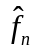 = (1 – 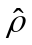)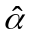 + y_{n} + 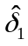z_{n} – 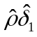z_{n-1}

where I_{t-1} contains y and z dated at t – 1 and earlier.

(iii) From part (i), it follows that the model with one lag of z and AR(1) serial correlation in the errors can be obtained from

y_{t} = α₀ + ρy_{t-1} + γ₁z_{t-1} + γ₂z_{t-2} + e_{t}, E(e_{t}|I_{t-1}) = 0

with α₀ = (1 − ρ)α, γ₁ = δ₁, and γ₂ = −ρδ₁ = −ργ₁. The key is that γ₂ is entirely determined (in a nonlinear way) by ρ and γ₁. So the model with a lag of z and AR(1) serial correlation is a special case of the more general model. (Note that the general model depends on four parameters, while the model from part (i) depends on only three.)

(iv) For forecasting, the AR(1) serial correlation model may be too restrictive. It may impose restrictions on the parameters that are not met. On the other hand, if the AR(1) serial correlation model holds, it captures the conditional mean E(y_{t}|I_{t-1}) with one fewer parameter than the general model; in other words, the AR(1) serial correlation model is more parsimonious. [See Harvey (1990) for ways to test the restriction γ₂ = −ργ₁, which is called a common factor restriction.]

18.9 Let 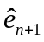 be the forecast error for forecasting y_{n+1}, and let 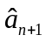 be the forecast error for forecasting Δy_{n+1}. By definition, = y_{n+1} − = y_{n+1} – (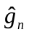 + y_{n}) = (y_{n+1} – y_{n}) − = Δy_{n+1} − = , where the last equality follows by definition of the forecasting error for Δy_{n+1}.

SOLUTIONS TO COMPUTER EXERCISES

C18.1 (i) The estimated GDL model is

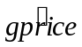 = .0013 + .081 gwage + .640 gprice₋₁
(.0003) (.031) (.045)
n = 284, R² = .454.

The estimated impact propensity is .081 while the estimated LRP is .081/(1 – .640) = .225. The estimated lag distribution is graphed below.

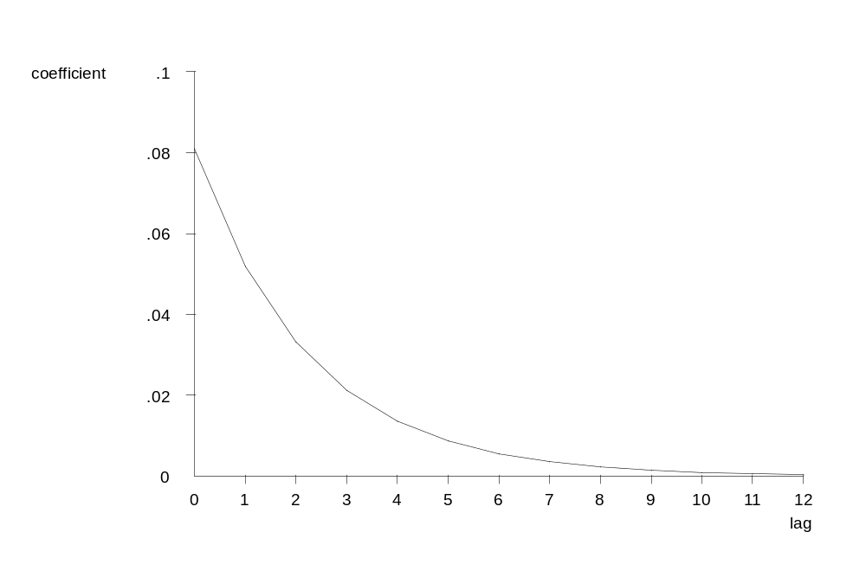
(ii) The IP for the FDL model estimated in Problem 11.5 was .119, which is substantially above the estimated IP for the GDL model. Further, the estimated LRP from GDL model is much lower than that for the FDL model, which we estimated as 1.172. Clearly we cannot think of the GDL model as a good approximation to the FDL model. One reason these are so different can be seen by comparing the estimated lag distributions (see below for the GDL model). With the FDL, the largest lag coefficient is at the ninth lag, which is impossible with the GDL model (where the largest impact is always at lag zero). It could also be that {u_{t}} in equation (18.8) does not follow an AR(1) process with parameter ρ, which would cause the dynamic regression to produce inconsistent estimators of the lag coefficients.

(iii) When we estimate the RDL from equation (18.16) we obtain

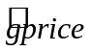 = .0011 + .090 gwage + .619 gprice₋₁ + .055 gwage₋₁
(.0003) (.031) (.046) (.032)
n = 284, R² = .460.

The coefficient on gwage₋₁ is not especially significant but we include it in obtaining the estimated LRP. The estimated IP is .09 while the LRP is (.090 + .055)/(1 – .619) .381. These are both slightly higher than what we obtained for the GDL, but the LRP is still well below what we obtained for the FDL in Problem 11.5. While this RDL model is more flexible than the GDL model, it imposes a maximum lag coefficient (in absolute value) at lag zero or one. For the estimates given above, the maximum effect is at the first lag. (See the estimated lag distribution below.) This is not consistent with the FDL estimates in Problem 11.5.
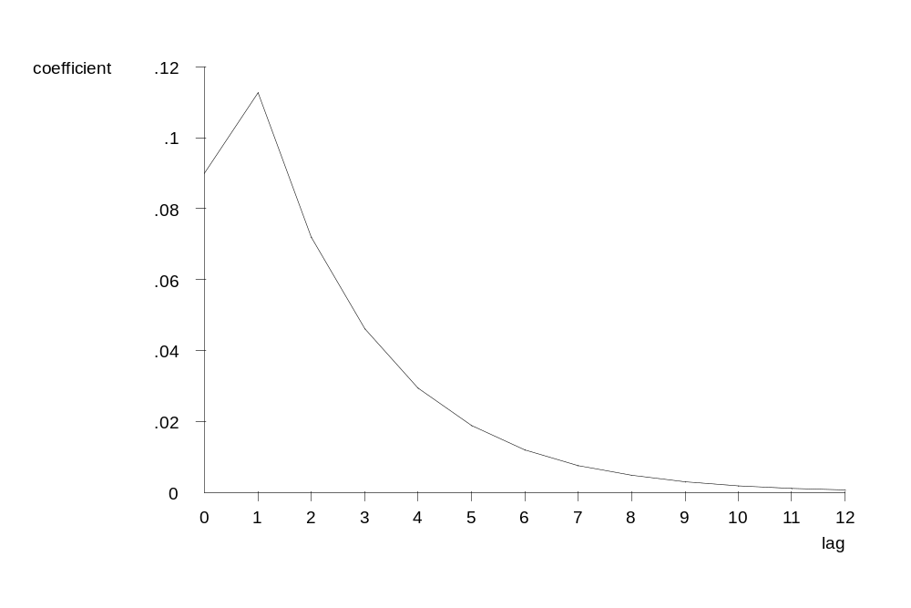

C18.2 (i) We run the regression

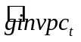 = –.786 – .956 log(invpc_{t-1}) + .0068 t
(.170) (.198) (.0021)
+ .532 ginvpc_{t-1} + .290 ginvpc_{t-2}
(.162) (.165)
n = 39, R² = .437,

where ginvpc_{t} = log(invpc_{t}) – log(invpc_{t-1}). The t statistic for the augmented Dickey-Fuller unit root test is –.956/.198 –4.82, which is well below –3.96, the 1% critical value obtained from Table 18.3. Therefore, we strongly reject a unit root in log(invpc_{t}). (Incidentally, remember that the t statistics on the intercept and time trend in this estimated equation to not have approximate t distributions, although those on ginvpc_{t-1} and ginvpc_{t-2} do under the usual null hypothesis that the parameter is zero.)

(ii) When we apply the regression to log(price_{t}) we obtain

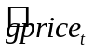 = –.040 – .222 log(price_{t-1}) + .00097 t
(.019) (.092) (.00049)
+ .328 gprice_{t-1} + .130 gprice_{t-2}
(.155) (.149)
n = 39, R² = .200,

Now the Dickey-Fuller t statistic is about –2.41, which is above –3.12, the 10% critical value from Table 18.3. [The estimated root is 1 – .222 = .778, which is much larger than for log(invpc_{t}).] We cannot reject the unit root null at a sufficiently small significance level.

(iii) Given the very strong evidence that log(invpc_{t}) does not contain a unit root, while log(price_{t}) may very well, it makes no sense to discuss cointegration between the two. If we take any nontrivial linear combination of an I(0) process (which may have a trend) and an I(1) process, the result will be an I(1) process (possibly with drift).

C18.3 (i) The estimated AR(3) model for pcip_{t} is

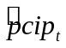 = 1.80 + .349 pcip_{t-1} + .071 pcip_{t-2} + .067 pcip_{t-2}
(0.55) (.043) (.045) (.043)
n = 554, R² = .166, 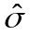 = 12.15.

When pcip_{t-4} is added, its coefficient is .0043 with a t statistic of about .10.

(ii) In the model

pcip_{t} = δ₀ + α₁pcip_{t-1} + α₂pcip_{t-2} + α₃pcip_{t-3} + γ₁pcsp_{t-1} + γ₂pcsp_{t-2} + γ₃pcsp_{t-3} + u_{t},

The null hypothesis is that pcsp does not Granger cause pcip. This is stated as H₀: γ₁ = γ₂ = γ₃ = 0. The F statistic for joint significance of the three lags of pcsp_{t}, with 3 and 547 df, is F = 5.37 and p-value = .0012. Therefore, we strongly reject H₀ and conclude that pcsp does Granger cause pcip.

(iii) When we add Δi3_{t-1}, Δi3_{t-2}, and Δi3_{t-3} to the regression from part (ii), and now test the joint significance of pcsp_{t-1}, pcsp_{t-2}, and pcsp_{t-3}, the F statistic is 5.08. With 3 and 544 df in the F distribution, this gives p-value = .0018, and so pcsp Granger causes pcip even conditional on past Δi3.

[Instructor’s Note: The F test for joint significance of Δi3_{t-1}, Δi3_{t-2}, and Δi3_{t-3} yields p-value = .228, and so Δi3 does not Granger cause pcip conditional on past pcsp.]

C18.4 We first run the regression gfr_{t} on pe_{t}, t, and t², and obtain the residuals, 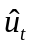. We then apply the augmented Dickey-Fuller test, with one lag of Δ, by regressing Δ on 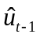 and Δ. There are 70 observations available for this last regression, and it yields −.165 as the coefficient on with t statistic = −2.76. This is well above –4.15, the 5% critical value [obtained from Davidson and MacKinnon (1993, Table 20.2)]. Therefore, we cannot reject the null hypothesis of no cointegration, so we conclude gfr_{t} and pe_{t} are not cointegrated even if we allow them to have different quadratic trends.

C18.5 (i) The estimated equation is

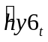 = .078 + 1.027 hy3_{t-1} − 1.021 Δhy3_{t} − .085 Δhy3_{t-1} − .104 Δhy3_{t-2}
(.028) (0.016) (0.038) (.037) (.037)
n = 121, R² = .982, = .123.

The t statistic for H₀: β = 1 is (1.027 – 1)/.016 1.69. We do not reject H₀: β = 1 at the 5% level against a two-sided alternative, although we would reject at the 10% level.

[Instructor’s Note: The standard errors on all slope coefficients can be used to construct t statistics with approximate t distributions, provided there is no serial correlation in {e_{t}}.]

(ii) The estimated error correction model is

= .070 + 1.259 Δhy3_{t-1} − .816 (hy6_{t-1} – hy3_{t-2})
(.049) (.278) (.256)
+ .283 Δhy3_{t-2} + .127 (hy6_{t-2} – hy3_{t-3})
(.272) (.256)
n = 121, R² = .795.

Neither of the added terms is individually significant. The F test for their joint significance gives F = 1.35, p-value = .264. Therefore, we would omit these terms and stick with the error correction model estimated in (18.39).

C18.6 (i) The equations using data through 1997 are

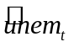 = 1.549 + .734 unem_{t-1}
(0.572) (.096)
n = 49, R² = .554, = 1.041
and
= 1.286 + .648 unem_{t-1} + .185 inf_{t-1}
(0.484) (.083) (.041)
n = 49, R² = .691, = .876.

The parameter estimates do not change by much. This is not very surprising, as we have added only one year of data.

(ii) The forecast for unem₁₉₉₈ from the first equation is 1.549 + .734(4.9) 5.15; from the second equation the forecast is 1.286 + .648(4.9) + .185(2.3) 4.89. The actual civilian unemployment rate for 1998 was 4.5. Once again the model that includes lagged inflation produces a better forecast.

(iii) There is no practical improvement in reestimating the parameters using data through 1997: 4.89 versus 4.90, which differs in a digit that is not even reported in the published unemployment series: our predicted unemployment rate would be 4.9% in both cases.

(iv) To obtain the two-step-ahead forecast we need the 1996 unemployment rate, which is 5.4. From equation (18.55), the forecast of unem₁₉₉₈ made after we know unem₁₉₉₆ is (1 + .732)(1.572) + (.732²)(5.4) 5.62. The one-step ahead forecast is 1.572 + .732(4.9) 5.16, and so it is better to use the one-step-ahead forecast, as it is much closer to 4.5.

C18.7 (i) The estimated linear trend equation using the first 119 observations and excluding the last 12 months is

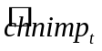 = 248.58 + 5.15 t
(53.20) (0.77)
n = 119, R² = .277, = 288.33.

The standard error of the regression is 288.33.

(ii) The estimated AR(1) model excluding the last 12 months is

= 329.18 + .416 chnimp_{t-1}
(54.71) (.084)
n = 118, R² = .174, = 308.17.

Because is lower for the linear trend model, it provides the better in-sample fit.

(iii) Using the last 12 observations for one-step-ahead out-of-sample forecasting gives an RMSE and MAE for the linear trend equation of about 315.5 and 201.9, respectively. For the AR(1) model, the RMSE and MAE are about 388.6 and 246.1, respectively. In this case, the linear trend is the better forecasting model.

[Instructor’s Note: In a model with a linear time trend and autoregressive term, both are statistically significant with = 285.03 – a slightly better in-sample fit than the linear trend model. But, using the last 12 months for one-step-ahead forecasting, RMSE = 316.15 and MAE = 202.73. Therefore, one actually does a bit worse in using the more general model compared with the simple linear trend.]

(iv) Using again the first 119 observations, the F statistic for joint significance of feb_{t}, mar_{t}, …, dec_{t} when added to the linear trend model is about 1.15 with p-value .328. (The df are 11 and 107.) So there is no evidence that seasonality needs to be accounted for in forecasting chnimp.

C18.8 (i) As can be seen from the following graph, gfr does not have a clear upward or downward trend. Starting from 1913, there is a sharp downward trend in fertility until the mid-1930s, when the fertility rate bottoms out. Fertility increased markedly until the end of the baby boom in the early 1960s, after which point it fell sharply and then leveled off.

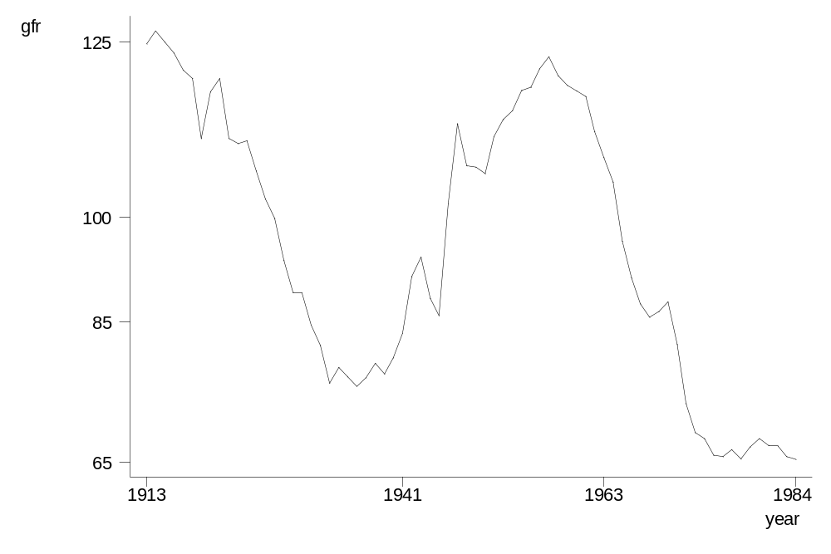
(ii) The regression of gfr_{t} on a cubic in t, using the data up through 1979, gives

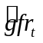 = 148.71 - 6.90 t + .243 t² − .0024 t³
(5.09) (0.64) (.022) (.0002)
n = 67, R² = .739, = 9.84.

If we use the usual t critical values, all terms are very statistically significant, and the R-squared indicates that this curve-fitting exercise tracks gfr_{t} pretty well, at least up through 1979.

(iii) The MAE is about 43.02.

(iv) The regression Δgfr_{t} on just an intercept, using data up through 1979, gives

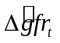 = –.871
(.543)
n = 66, = 4.41.

(The R-squared is identically zero since there are no explanatory variables. But , which estimates the standard deviation of the error, is comparable to that in part (ii), and we see that it is much smaller here.) The t statistic for the intercept is about –1.60, which is not significant at the 10% level against a two-sided alternative. Therefore, it is legitimate to treat gfr_{t} as having no drift, if it is indeed a random walk. (That is, if gfr_{t} = α₀ + gfr_{t-1} + e_{t}, where {e_{t}} is zero-mean, serially uncorrelated process, then we cannot reject H₀: α₀ = 0.)

(v) The prediction of gfr_{n+1} is simply gfr_{n}, so the predication error is simply Δgfr_{n+1} = gfr_{n+1} – gfr_{n}. Obtaining the MAE for the five prediction errors for 1980 through 1984 gives MAE .840, which is much lower than the 43.02 obtained with the cubic trend model. The random walk is clearly preferred for forecasting.

(vi) The estimated AR(2) model for gfr_{t} is

= 3.22 + 1.272 gfr_{t-1} – .311 gfr_{t-2}
(2.92) (0.120) (.121)
n = 65, R² = .949, = 4.25.

The second lag is significant. (Recall that its t statistic is valid even though gfr_{t} apparently contains a unit root: the coefficients on the two lags sum to .961.) The standard error of the regression is slightly below that of the random walk model.

(vii) The out-of-sample forecasting performance of the AR(2) model is worse than the random walk without drift: the MAE for 1980 through 1984 is about .991 for the AR(2) model.

[Instructor’s Note: As a third possibility, you might have the students estimate an AR(1) model for ∆gfr_{t} − that is, impose the unit root in the AR(2) model. The resulting MAE is about .879, so it is better to impose the unit root than to estimate the unrestricted AR(2). But it still does less well than the simple random walk without drift.]

C18.9 (i) Using the data up through 1989 gives

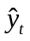 = 3,186.04 + 116.24 t + .630 y_{t-1}
(1,163.09) (46.31) (.148)
n = 30, R² = .994, = 223.95.

(Notice how high the R-squared is. However, it is meaningless as a goodness-of-fit measure because {y_{t}} has a trend, and possibly a unit root.)

(ii) The forecast for 1990 (t = 32) is 3,186.04 + 116.24(32) + .630(17,804.09) 18,122.30, because y is $17,804.09 in 1989. The actual value for real per capita disposable income was $17,944.64, and so the forecast error is –$177.66.

(iii) The MAE for the 1990s, using the model estimated in part (i), is about 371.76.

(iv) Without y_{t-1} in the equation, we obtain

= 8,143.11 + 311.26 t
(103.38) (5.64)
n = 31, R² = .991, = 280.87.

The MAE for the forecasts in the 1990s is about 718.26. This is much higher than for the model with y_{t-1}, so we should use the AR(1) model with a linear time trend.

C18.10 (i) The AR(1) model for Δr6, estimated using all but the last 16 observations, is

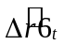 = .047 – .179 Δr6_{t-1}
(.131) (.096)
n = 106, R² = .032, 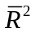 = .023.

The RMSE for forecasting one-step-ahead over the last 16 quarters is about .704.

(ii) The equation with spr_{t-1} included is

= .372 – .171 Δr6_{t-1} – 1.045 spr_{t-1}
(.195) (.095) (0.474)
n = 106, R² = .076, = .058.

The RMSE is about .788, which is higher than the RMSE without the error correction term. Therefore, while the EC term improves the in-sample fit (and is statistically significant), it actually hampers out-of-sample forecasting.

(iii) To make the forecasting exercises comparable, we exclude the last 16 observations to estimate the cointegrating parameters. The CI coefficient is about 1.028. The estimated error correction model is

= .372 – .171 Δr6_{t-1} – 1.045 (r6_{t-1} – 1.028 r3_{t-1})
(.195) (.095) (0.474)
n = 106, R² = .058, = .040,

which shows that this fits worse than the EC model when the cointegrating parameter is assumed to be one. The RMSE for the last 16 quarters is .782, so this works slightly better. But both versions of the EC model are dominated by the AR(1) model for Δr6_{t}.

[Instructor’s Note: Because Δr6_{t-1} is only marginally significant in the AR(1) model, its coefficient is small, and the intercept is also very small and insignificant, you might have the students use zero to predict Δr6 for each of the last 16 quarters. In other words, the “model” for r6 is simply 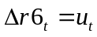, where 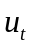 is an unpredictable sequence with zero mean. The resulting RMSE is about .657, which means this works best of all. The lesson is that econometric methods are not always called for, or even desirable.]

(iv) The conclusions would be identical because, as shown in Problem 18.9, the one-step-ahead errors for forecasting r6_{n+1} are identical to those for forecasting Δr6_{n+1}.

C18.11 (i) For lsp500, the ADF statistic without a trend is t = −.79; with a trend, the t statistic is −2.20. This are both well above their respective 10% critical values. In addition, the estimated roots are quite close to one. For lip, the ADF statistic without a trend is −1.37 without a trend and −2.52 with a trend. Again, these are not close to rejecting even at the 10% levels, and the estimated roots are very close to one.

(ii) The simple regression of lsp500 on lip gives

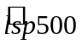 = −2.402 + 1.694 lip
(.095) (.024)

n = 558, R² = .903

The t statistic for lip is over 70, and the R-squared is over .90. These are hallmarks of spurious regressions.

(iii) Using the residuals obtained in part (ii), the ADF statistic (with two lagged changes) is −1.57, and the estimated root is over .99. There is no evidence of cointegration. (The 10% critical value is −3.04.)

(iv) After adding a linear time trend to the regression from part (ii), the ADF statistic applied to the residuals is −1.88, and the estimated root is again about .99. Even with a time trend there is no evidence of cointegration.

(v) It appears that lsp500 and lip do not move together in the sense of cointegration, even if we allow them to have unrestricted linear time trends. The analysis does not point to a long-run equilibrium relationship.

C18.12 (i) The F statistic for the second and third lags, with 2 and 550 degrees of freedom, gives F = 3.76 and p-value = .024.

(ii) When pcsp_{t-1} is added to the AR(3) model in part (i), its coefficient is about .031 and its
t statistic is about 2.40. Therefore, we conclude that pcsp does Granger cause pcip.

(iii) The heteroskedasticity-robust t statistic is 2.47, so the conclusion from part (ii) does not change.

C18.13 (i) The DF statistic is about −3.31, which is to the left of the 2.5% critical value (−3.12), and so, using this test, we can reject a unit root at the 2.5% level. (The estimated root is about .81.)

(ii) When two lagged changes are added to the regression in part (i), the t statistic becomes −1.50, and the root is larger (about .915). Now, there is little evidence against a unit root.

(iii) If we add a time trend to the regression in part (ii), the ADF statistic becomes −3.67, and the estimated root is about .57. The 2.5% critical value is −3.66, and so we are back to fairly convincingly rejecting a unit root.

(iv) The best characterization seems to be an I(0) process about a linear trend. In fact, a stable AR(3) about a linear trend is suggested by the regression in part (iii).

(v) For prcfat_{t}, the ADF statistic without a trend is −4.74 (estimated root = .62) and with a time trend the statistic is −5.29 (estimated root = .54). Here, the evidence is strongly in favor of an I(0) process whether or not we include a trend.

